**MUTLITENANCY IN SONARQUBE**

1. Create a new project in Sonarqube with any suitable name Ex: DemoProject1

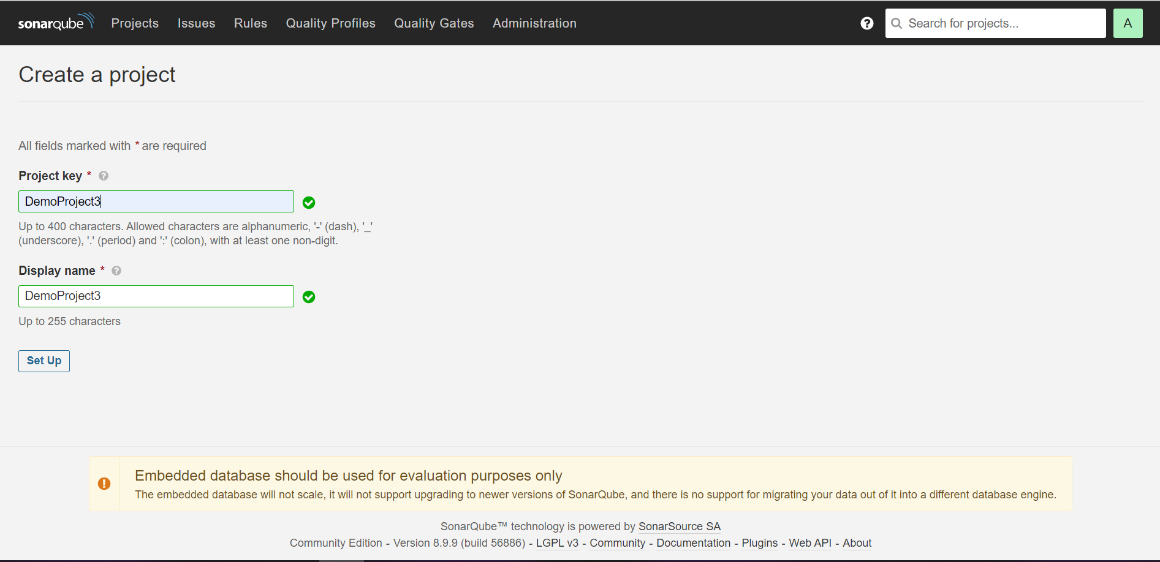

1. Go to Administration tab 🡪 Security 🡪 Users and create a user with a suitable name Ex: user3 and provide details for login, name and password for user3 and click on create.

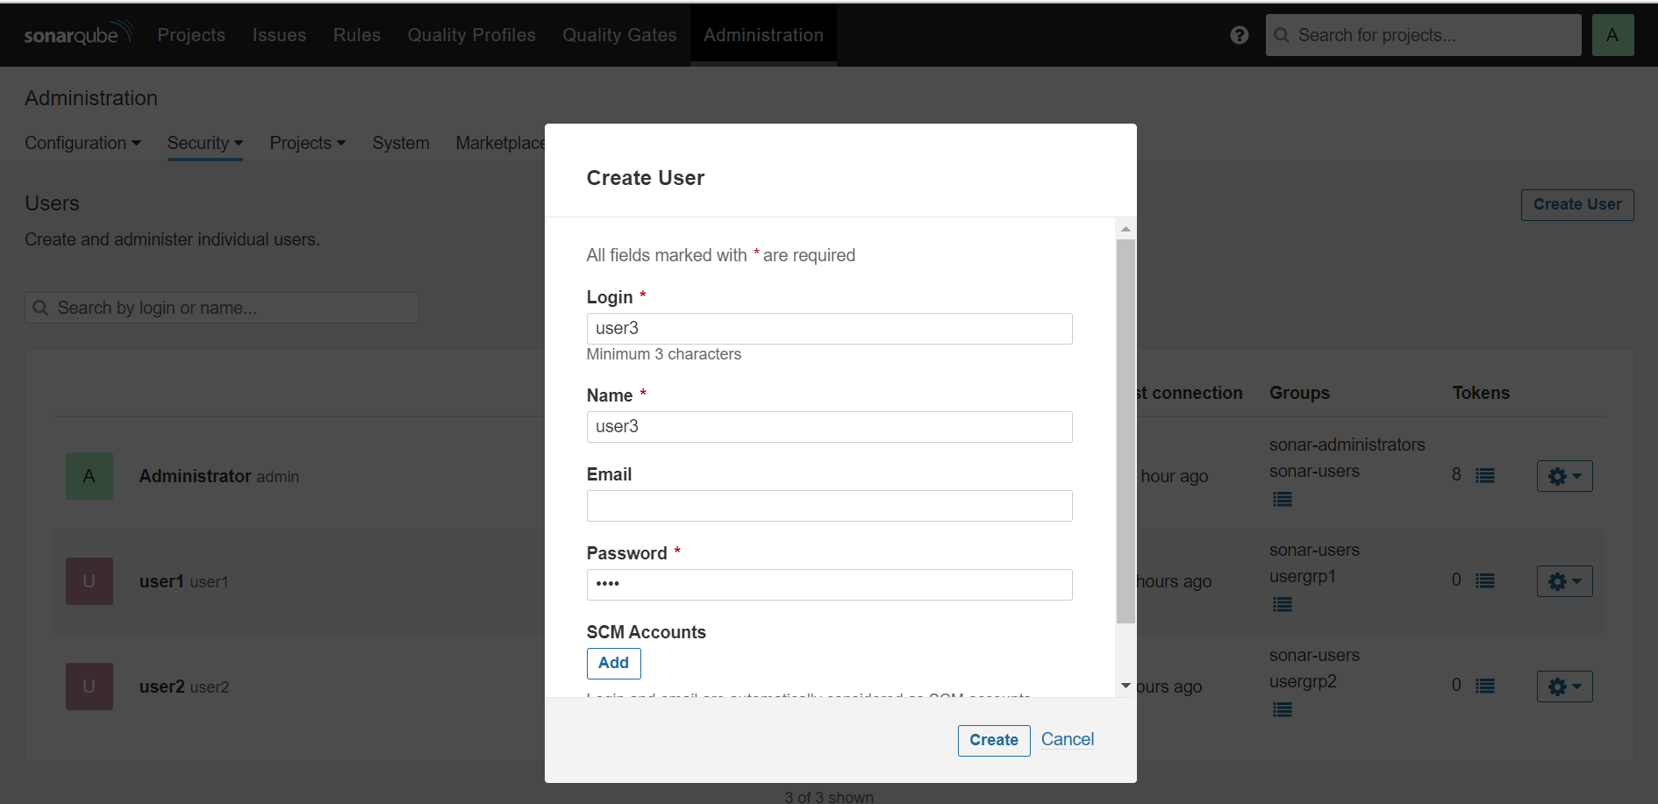

1. Again, go to Administration tab 🡪 Security 🡪 Groups and create a group with a suitable name so that only user3 can access the group Ex: usergrp3 and click on create.

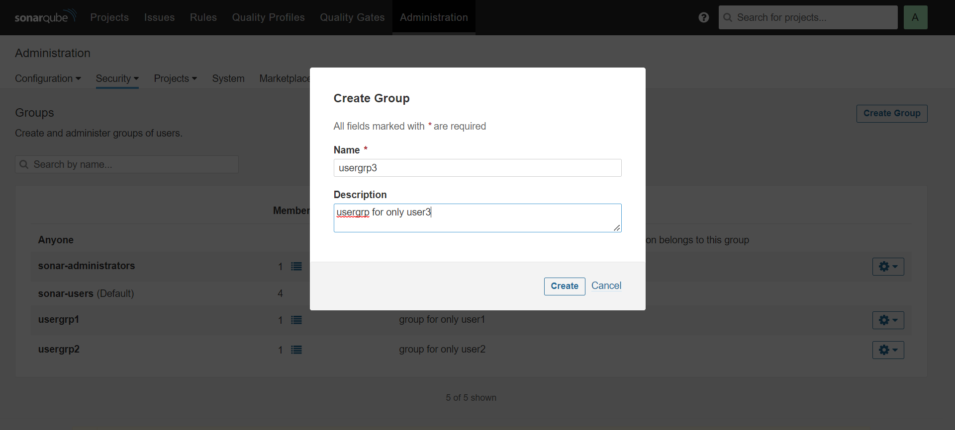

1. Again Administration tab 🡪 Security 🡪 Users. Under user3 add the newly created group(usergrp3) and click on done.

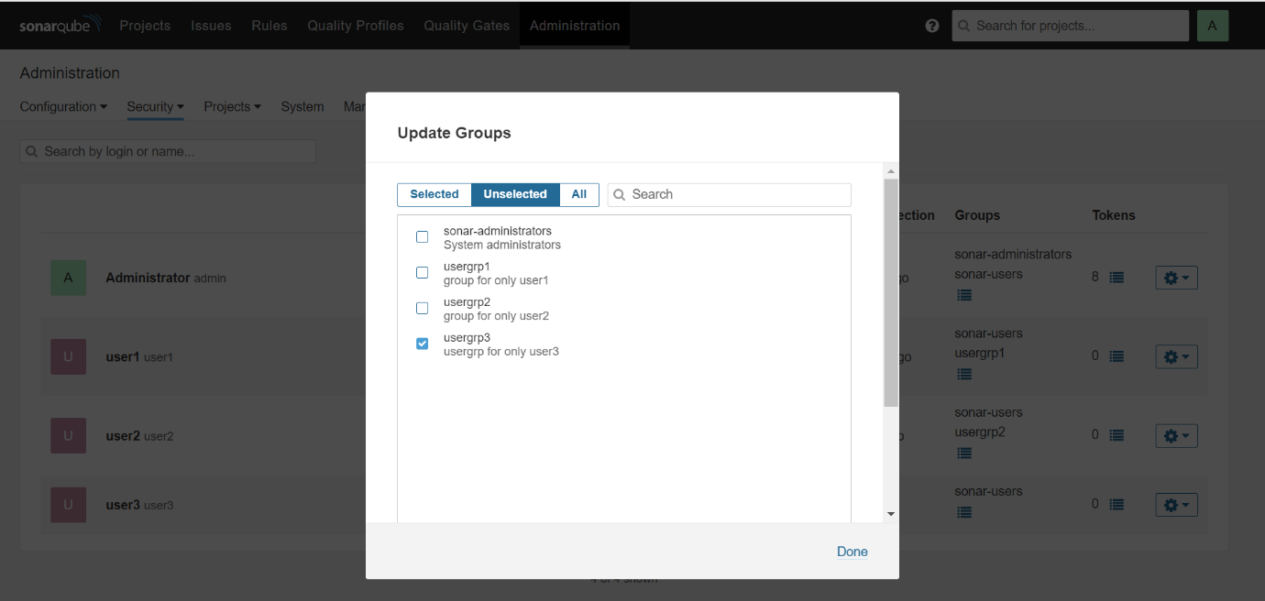

1. Go to security and under global permissions change the configuration for the user3.

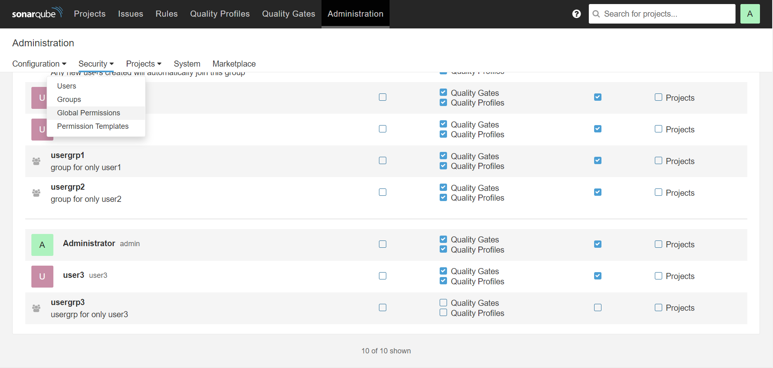

1. Under the Projects tab click on DemoProject3.

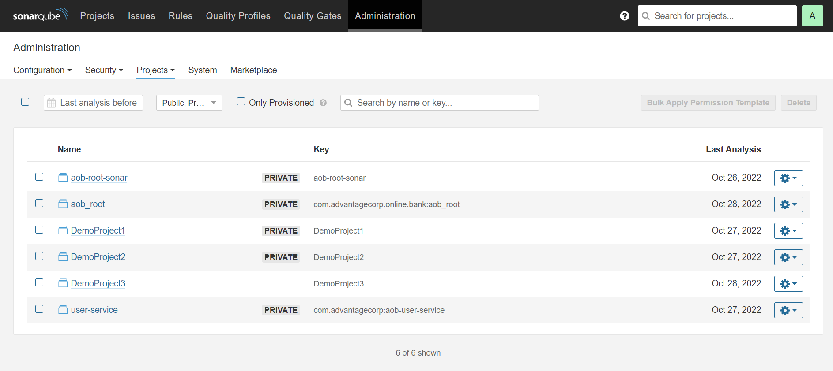

1. Click on Permissions under project settings.

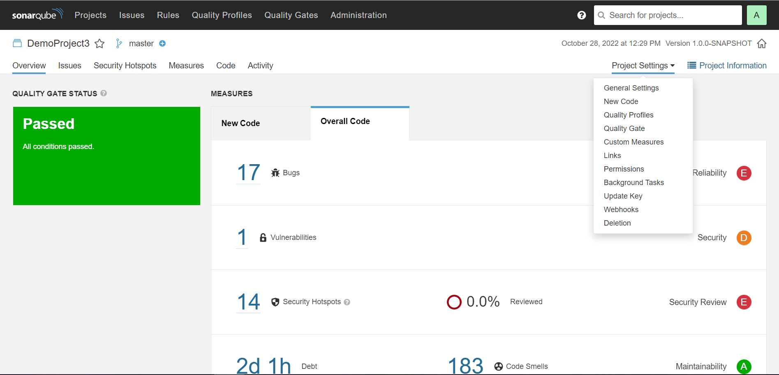

1. Change the project setting from Public to Private so that only specified users can have access.

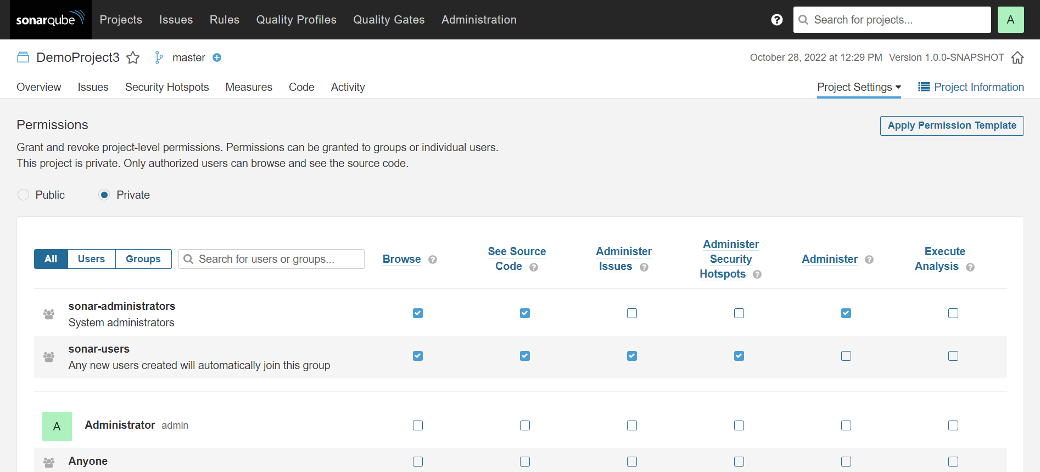

1. Under Groups in DemoProject3 provide access to only usergrp3 so that user3 has access to only DemoProject3.

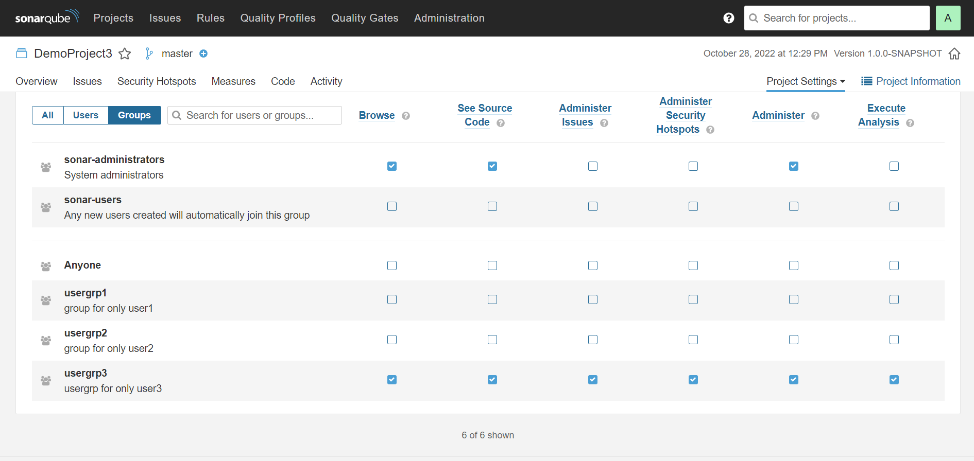

*Note: Settings can be changed according to our requirements. Here we have provided DemoProject3 access to only user3 and user3 has access to only usergrp3.*

1. Logout and Login with user3 credentials.

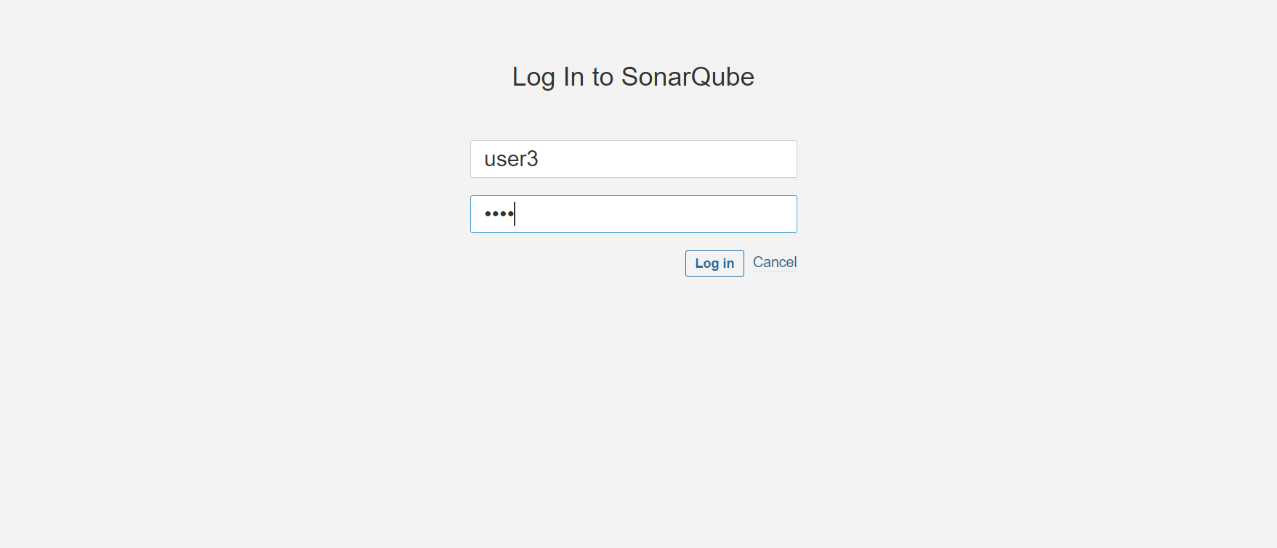

1. Only DemoProject3 is visible to user3 and hence we have achieved multitenancy in Sonarqube.

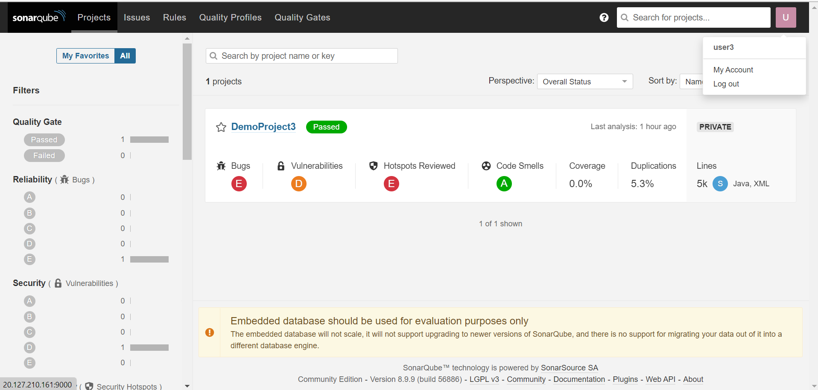

Connecting Jenkins pipeline to a specified project in Sonarqube :

1. Generate a secret token for DemoProject3 by providing any suitable name.

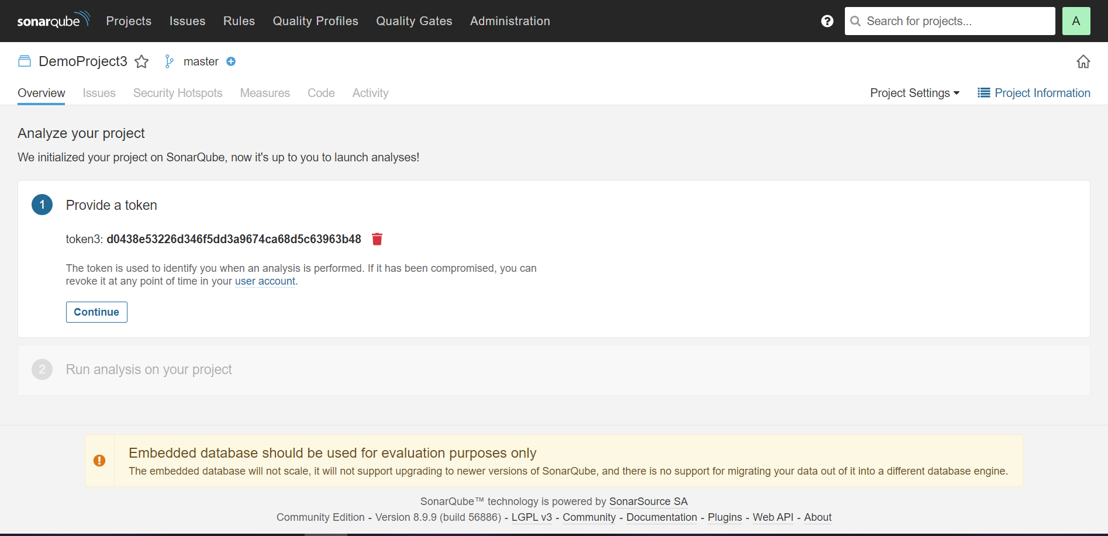

1. Check the project key and project name.



1. Create a demo project in Jenkins with a basic pipeline project.

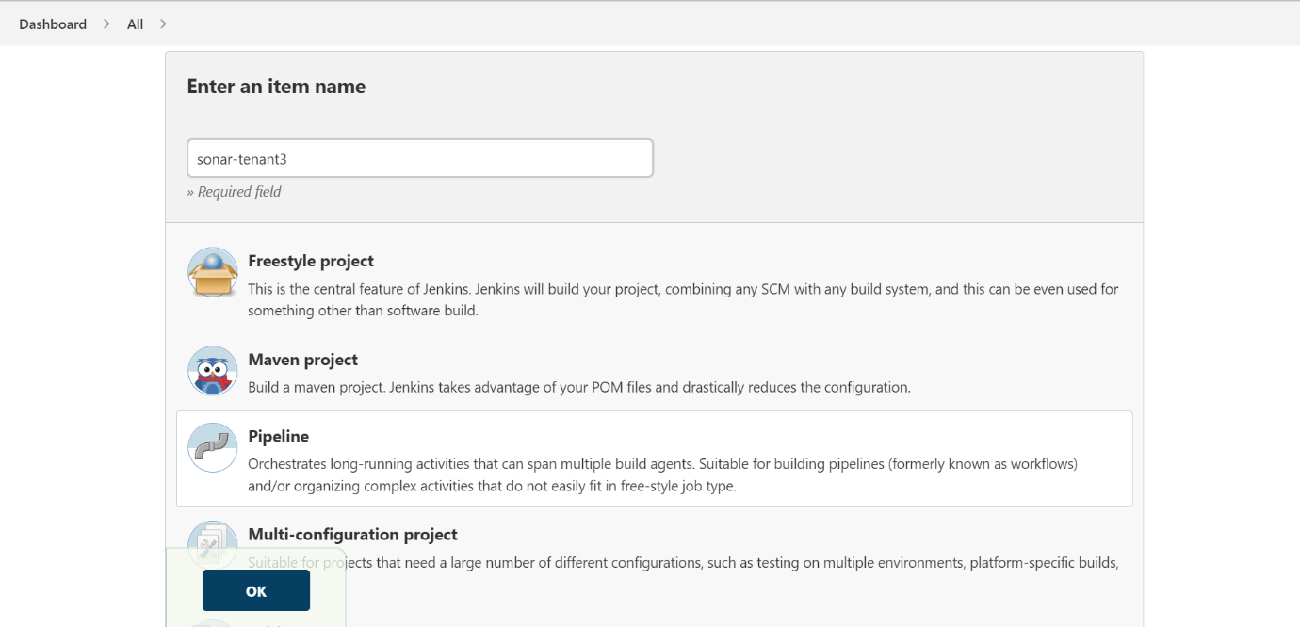

1. Update the pipeline with the Project key, Project name, and Authentication token and build the pipeline.

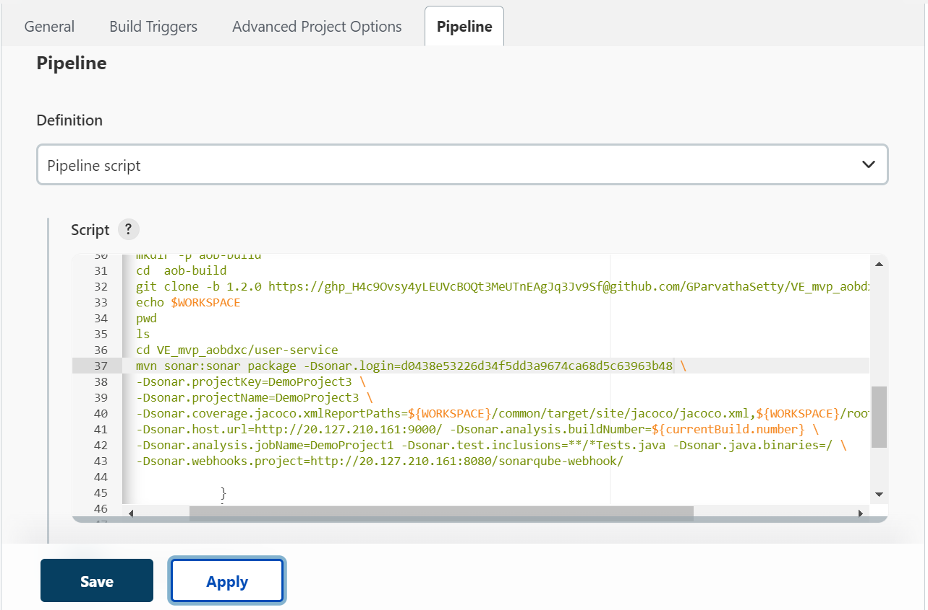

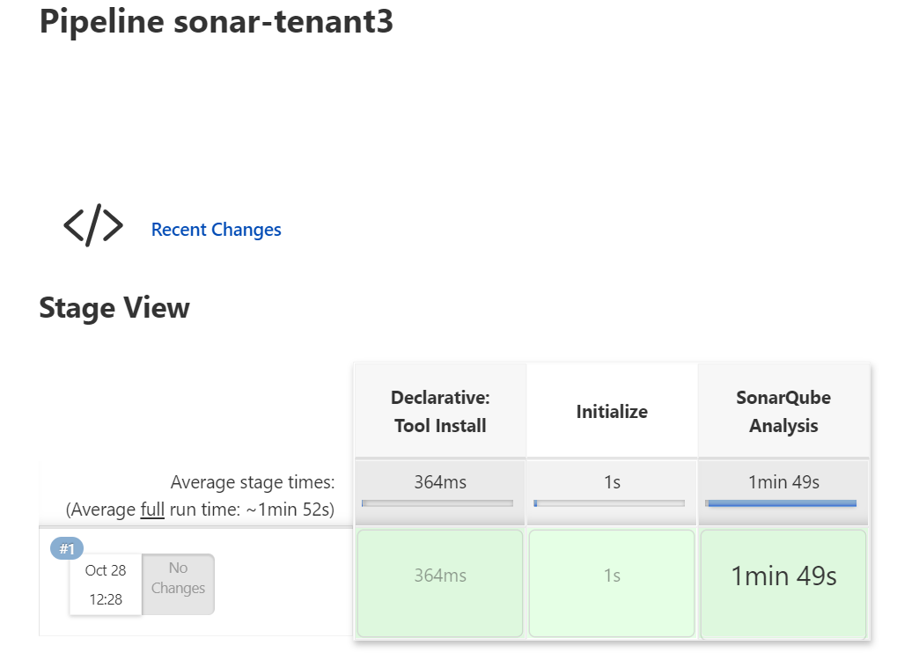

1. The output of the pipeline is reflected in DemoProject3.

